Computer Aided Mathematics Visualization

Practice (2023) – GeoGebra Practice Problems

Submitted To: Dr. Kinga Tünde Kruppa
Submitted By: Mahdi Ashraf
Submission Date: 2023/10/13

Problem – 1:
Correct Answer: option (b)
Explanation:
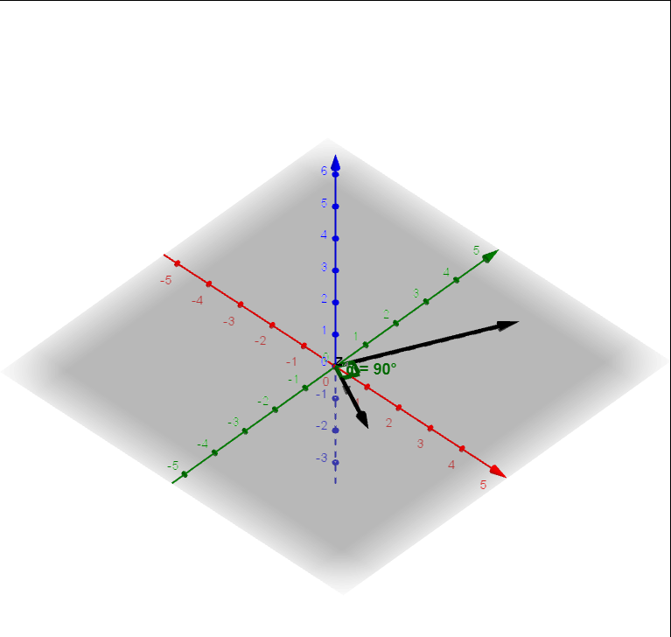
Fig – 1(b)

In the picture we can see that vector, v = 2i+4j and z₁ = 2i-j vector has dot product 0. And the angle between them is 90 degrees, which visually explains why the dot product is zero.

Option (a) and (c) are both incorrect because –
The cross product becomes 0 when two vectors have the same direction but differs in magnitude.
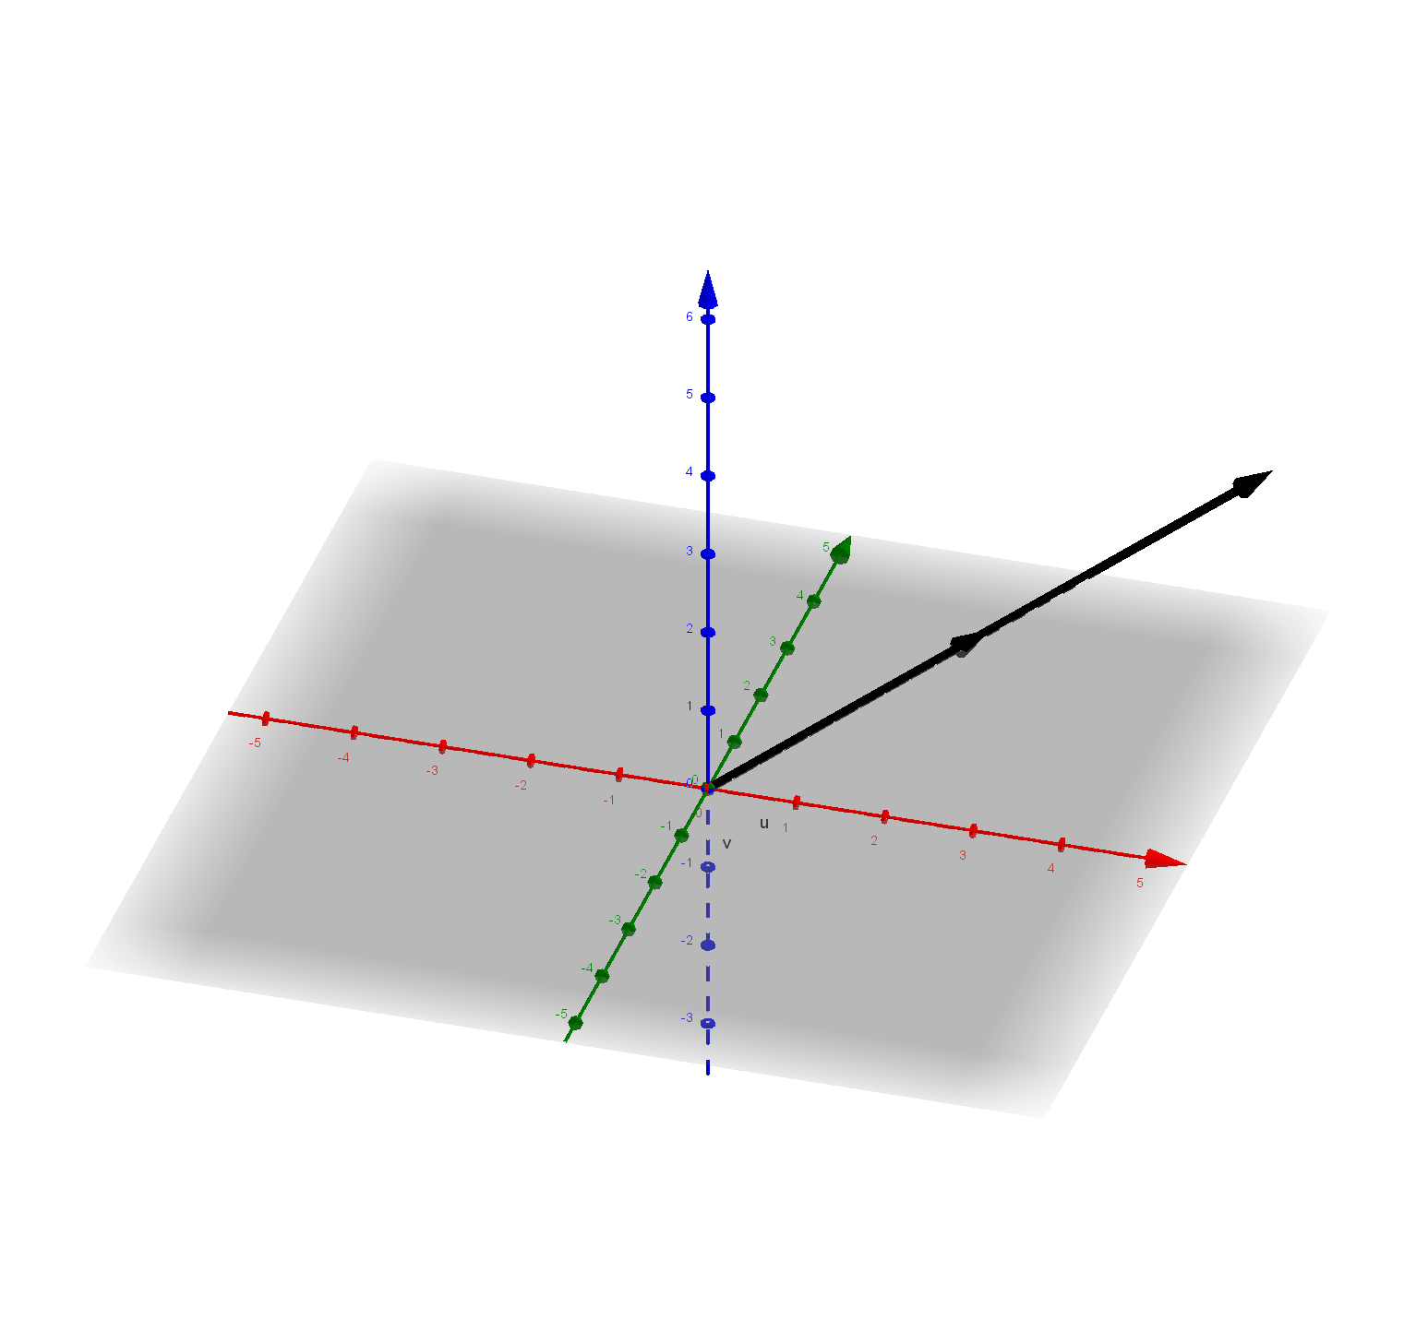
Fig – 1(a)

As Expected, we cannot see the cross product vector of vector v = 2i+4j and u = 4i+8j. The angle between
Them is 0 degrees.

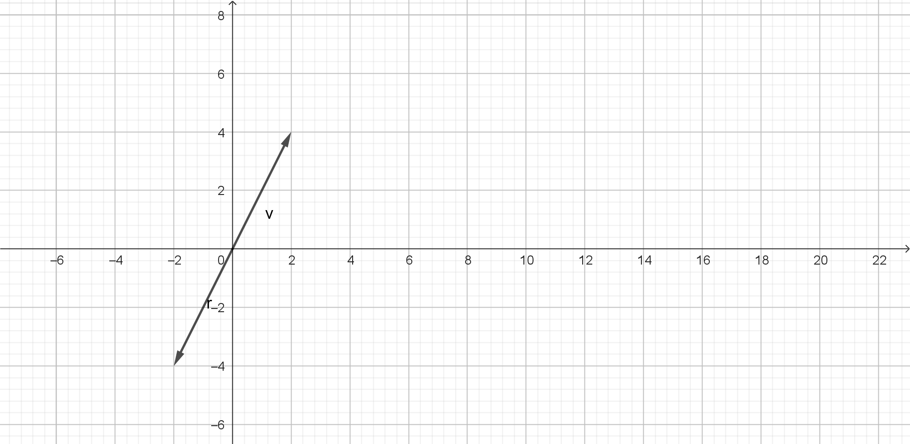
Fig – 1(c)

In 1(c), we can see that vector, v = 2i+4j and vector , r = -2i-4j reside in opposite directions but their dot product is -20; not 0.
The command view-
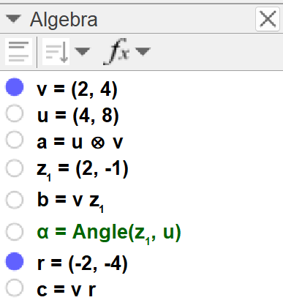

Problem – 2:
The answer is false. The function intersects y Axis at (0,-3).
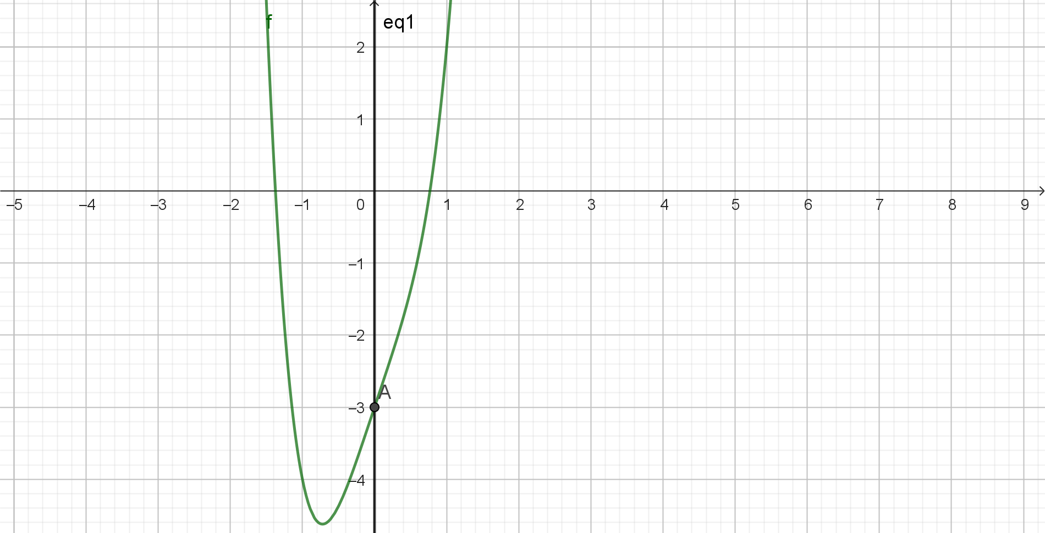
Fig – 2
The command View-
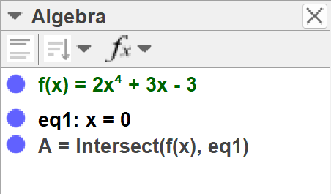

Problem – 3:

The answer is true. If we plugin x(A); where A = (2,4); in the function f(x) = 5x-6; we get 4 as answer.

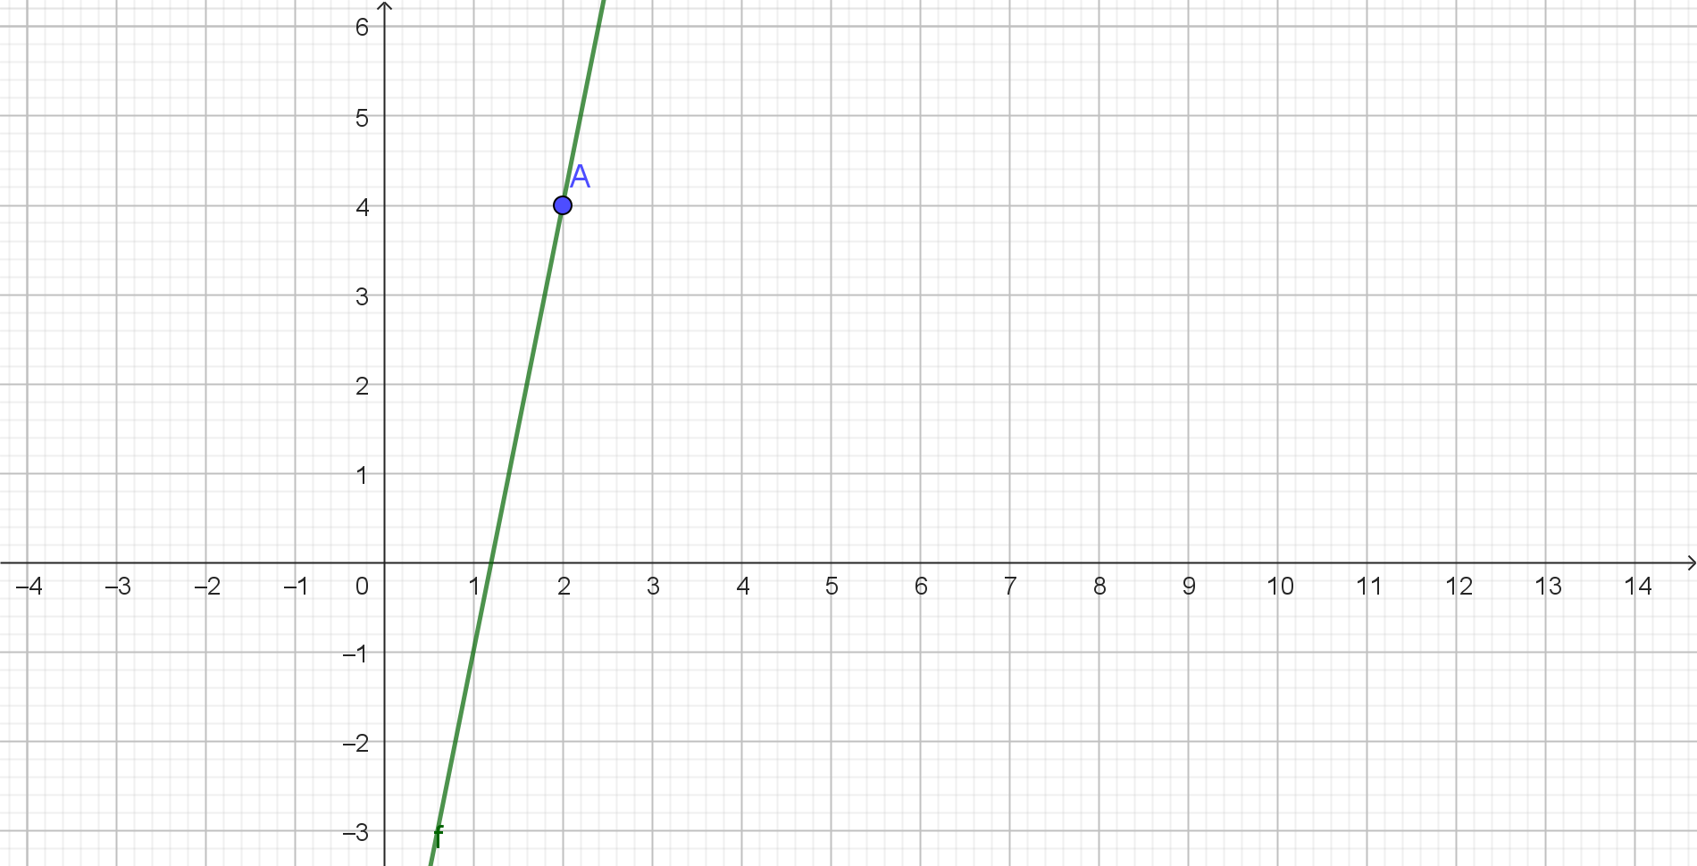
Fig – 3
The Command View-
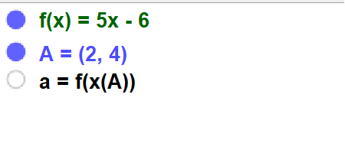
Problem – 4:

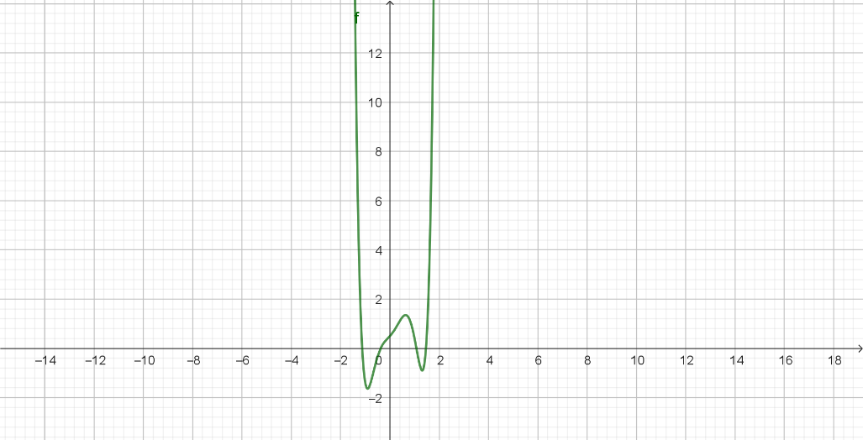

Fig – 4(a)

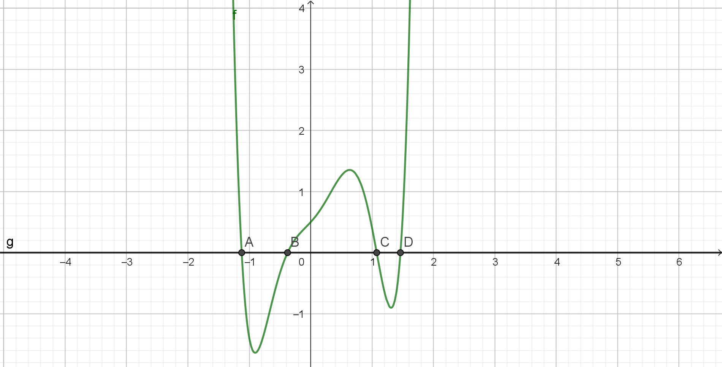
Fig – 4(b)
Here, we used the Intersect command between the function f(x) and y = 0. As shown in the picture, there
4 zeros of the function.
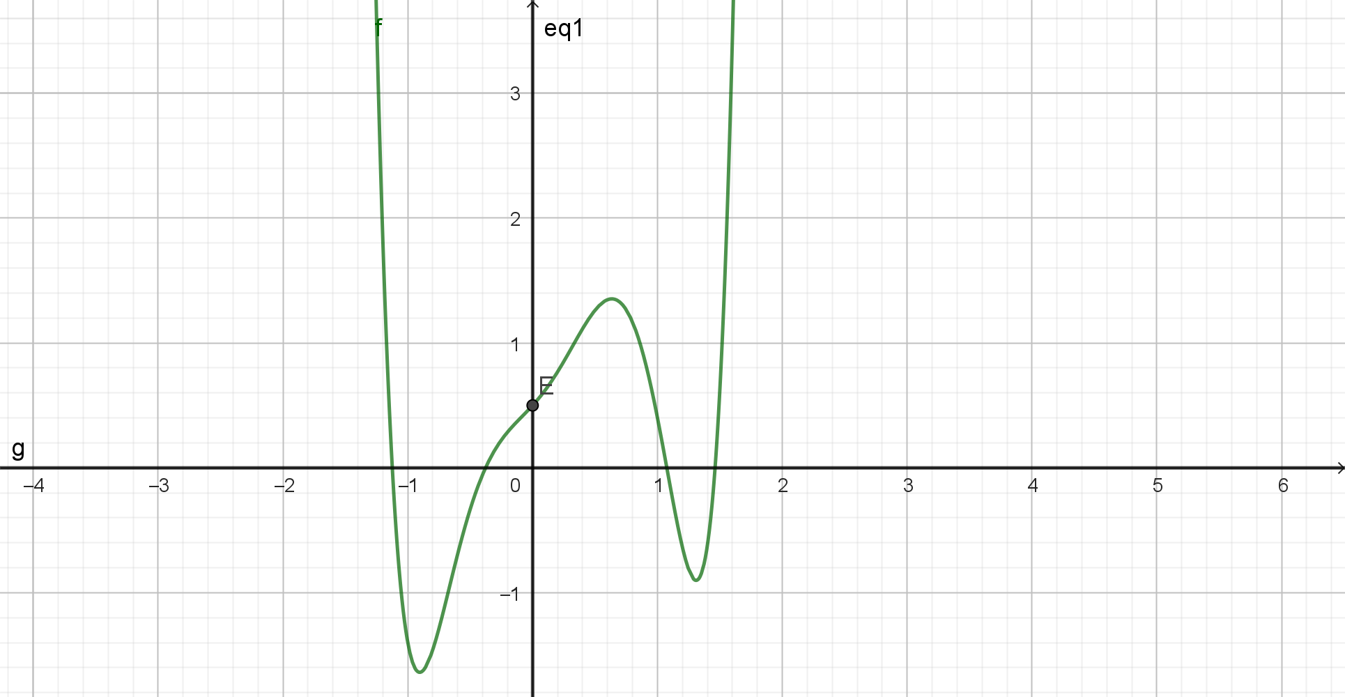
Fig – 4(c)
The function f(x) and x=0 or y Axis intersects at (0,0.5). In order to be a zero of a function, the function
must return output 0. So, x= 0 is not a zero of the function.
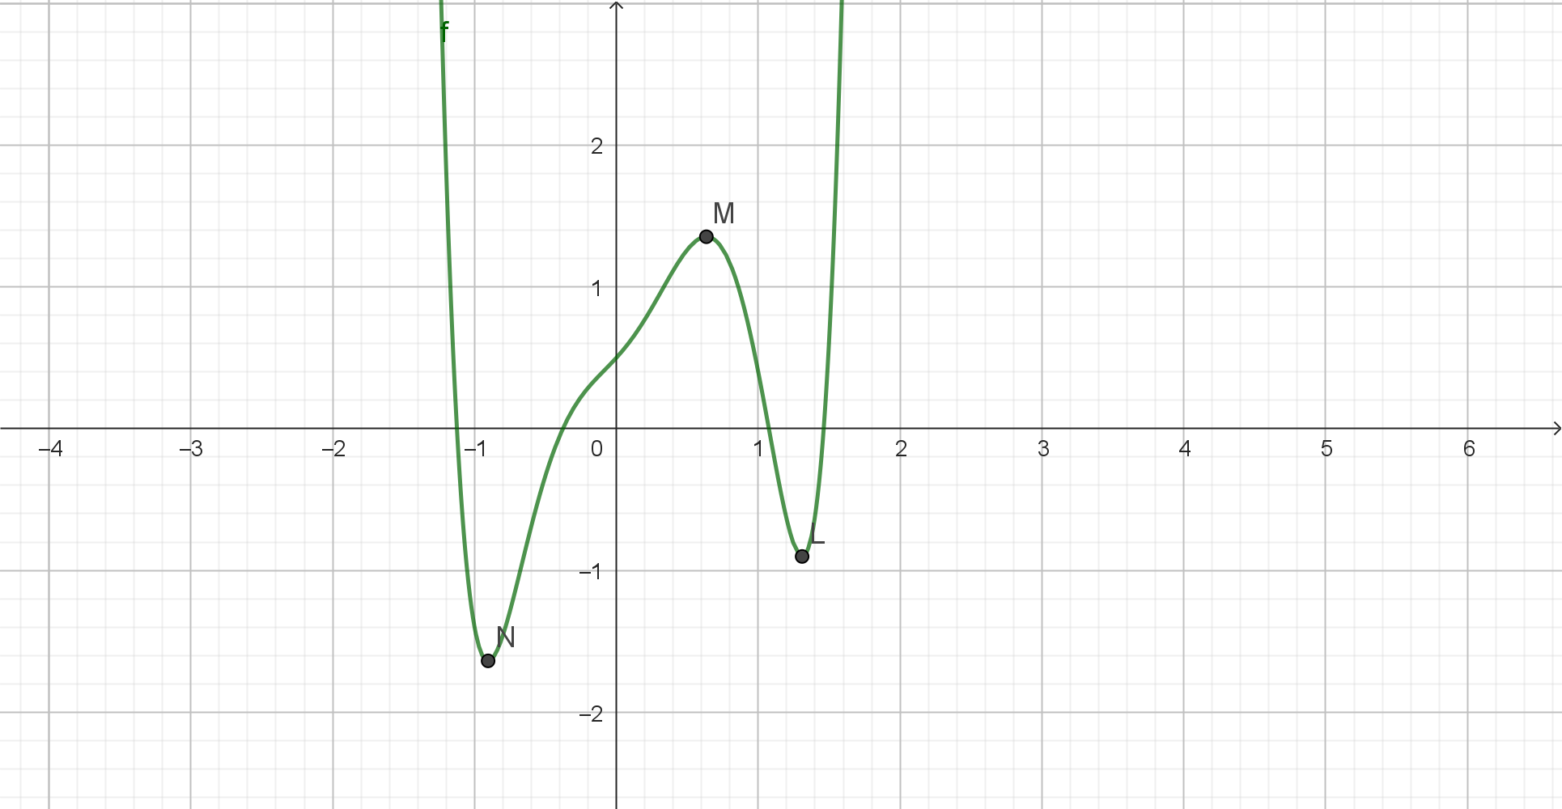
Fig – 4(d)
In order to get the maximum N,M and L; we first differentiated the function f(x). Then we deduced the
zeros of the function f’(x) and plugged them back into the function f(x).

For question 4(e), we deduced f’’(x) and plugged in the domain of the zeros of f’(x). We can see that, for
L and N; the value becomes positive; which means these points are minima. For M, the value becomes
Negative, which means M is a maxima.
Now, this function f(x) has 1 global minima N, 1 local minima L and 1 local maxima M.
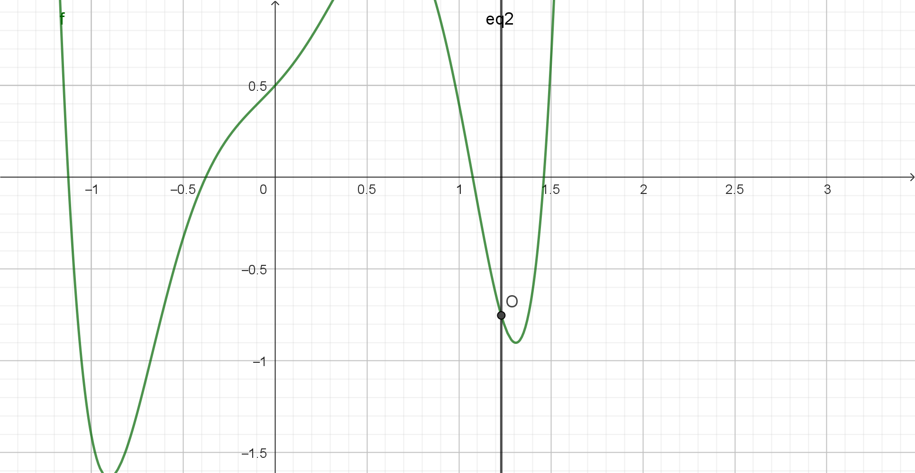
Fig – 4(f)
We used Intersect command between the function f(x) and x = 1.23. The intersection point O is (1.23,
-0.75).
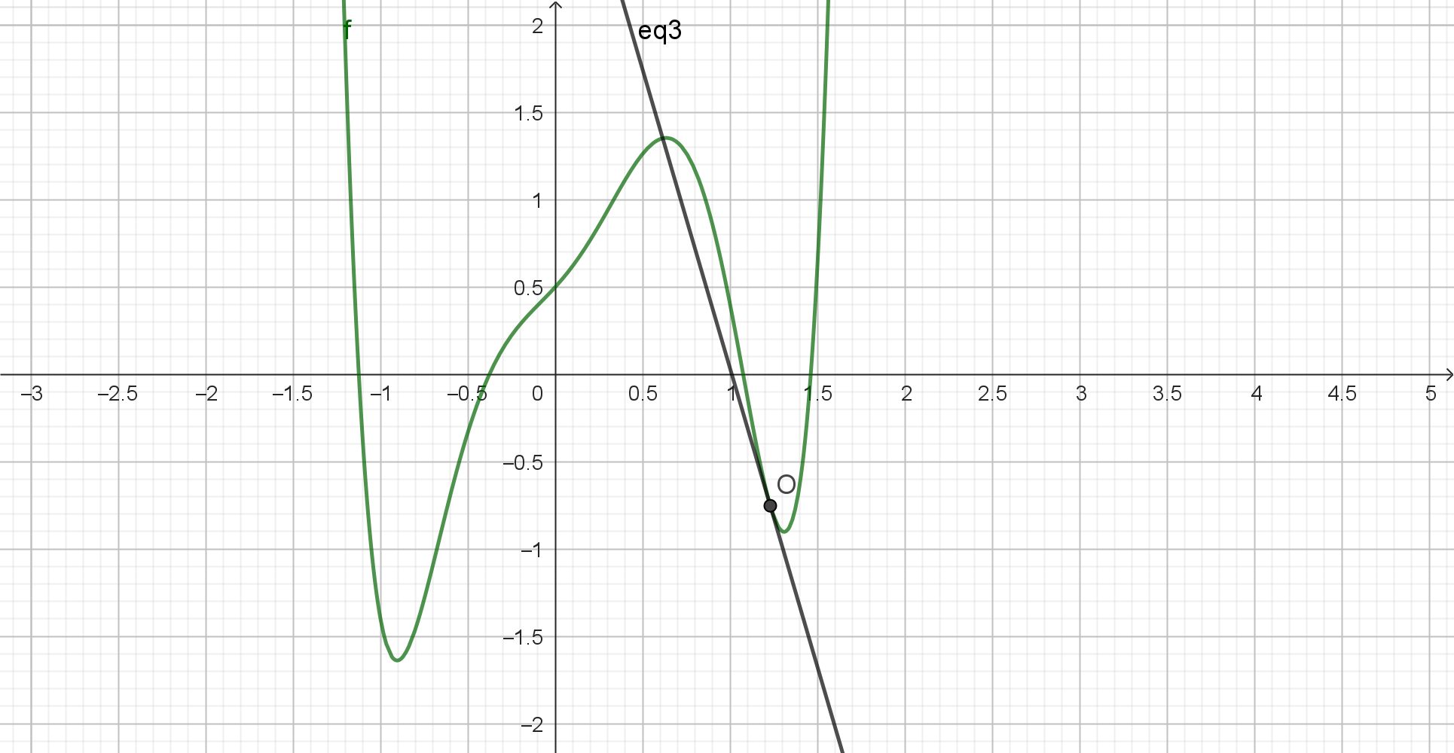
Fig – 4(g)
We know that f’(x) is the derivative of the function f(x), and if we plugin x value of O point at f’(x); we
Will get the slope of the tangent line. We used the slope and slope intercept form of linear equation to
Draw the tangent line. The equation is (y – y(O)) = f’(x(O))(x – x(O))
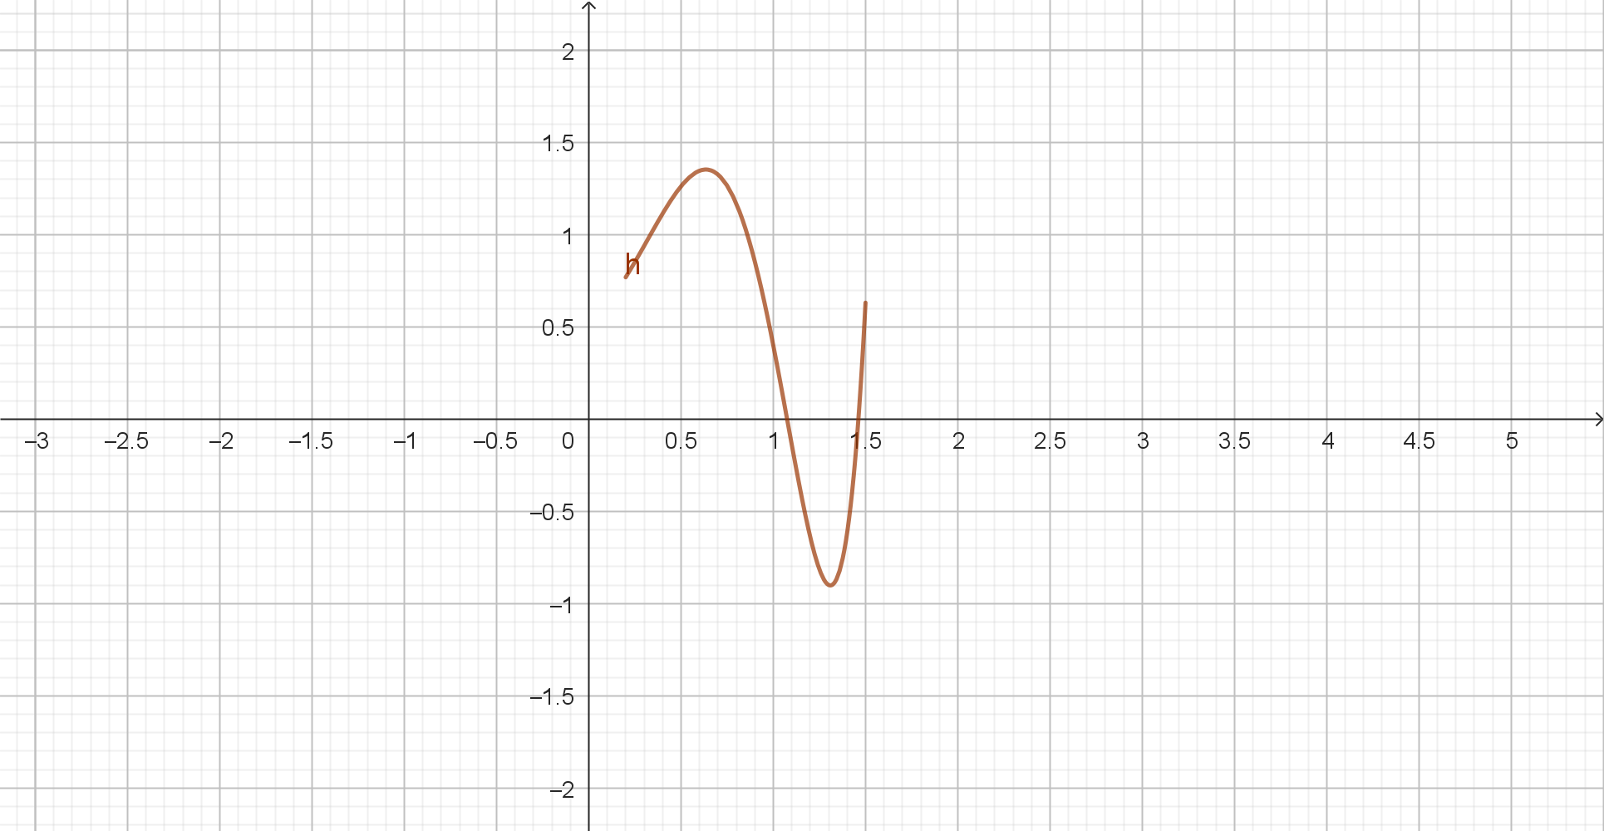
Fig – 4(h)

The command view-

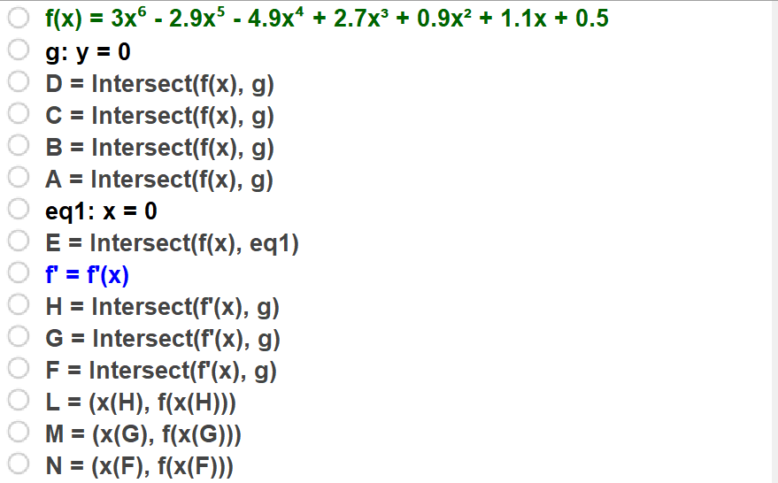
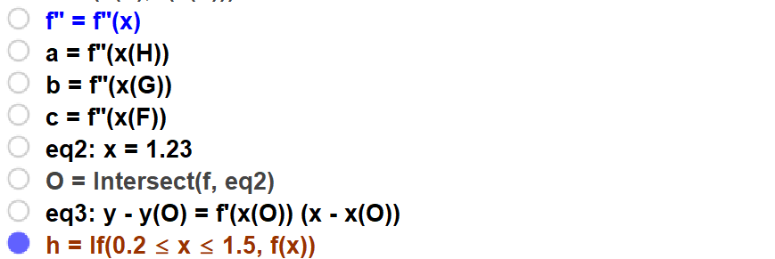

Problem – 5:
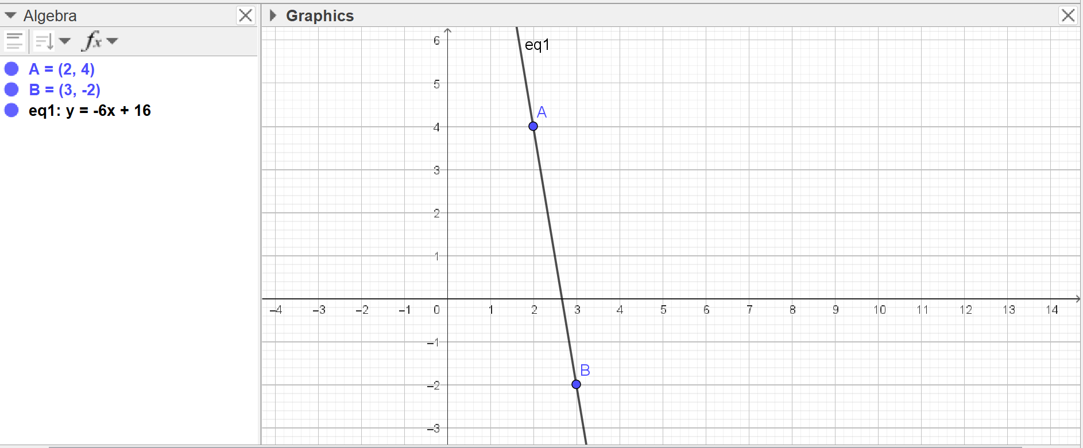
Fig – 5
As shown in the figure, we drew the line and from the slope intercept form we can see that the slope is -6.

Problem – 6:
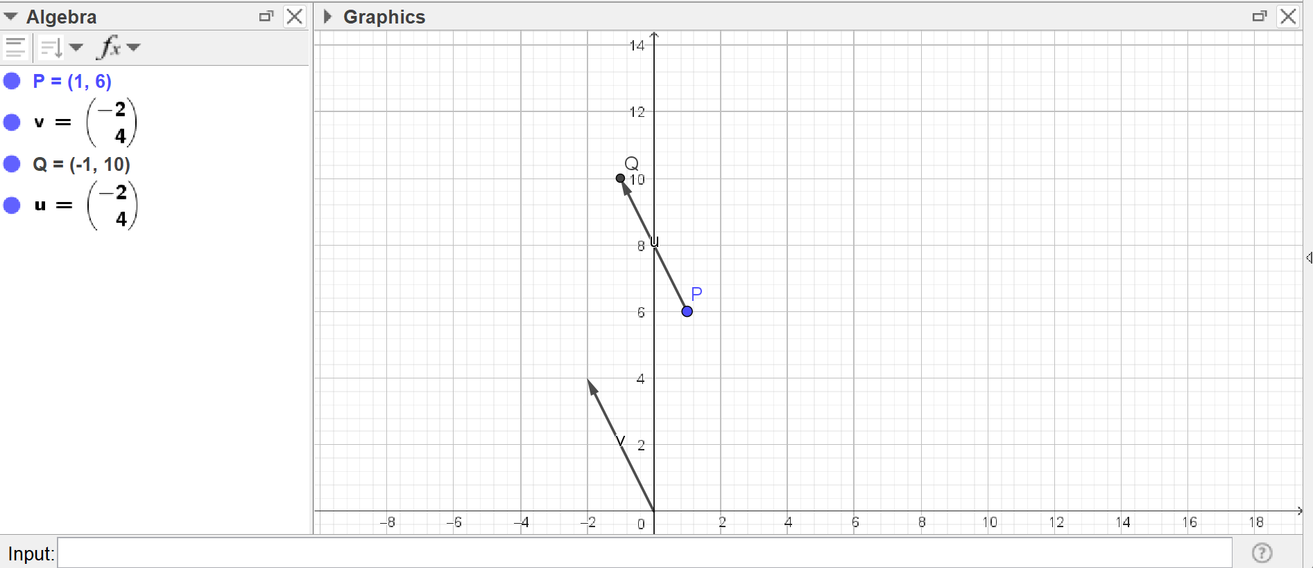
Fig – 6
As shown in the figure, the tip point of the vector is at (-1,10).

Problem – 7:
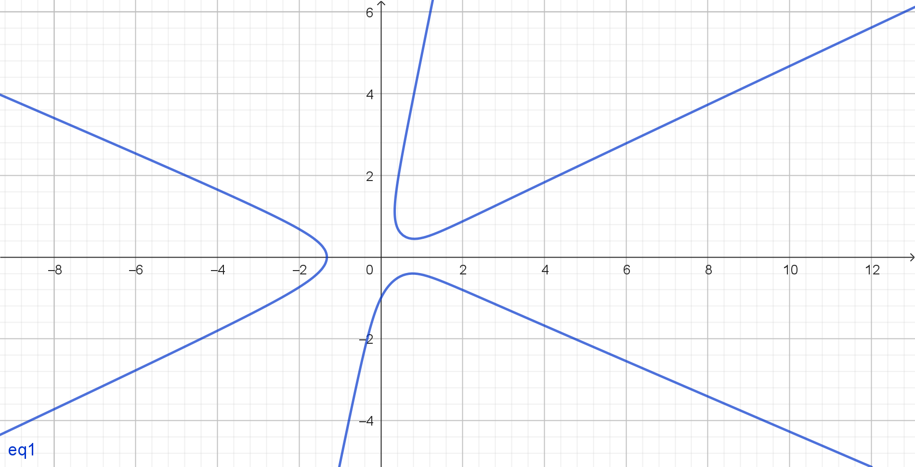
Fig – 7(a)
The above figure shows the graph of function f(x,y) = 0;where f(x,y) = x³+y³-5xy²-x+1. It is an implicit
Function.
7(b) - This shape cannot be converted to an explicit function. Partly because, it’s a equation where for
One domain there are 2 range points. So without implicit equation it is not really possible to plot the
Explicit equation.
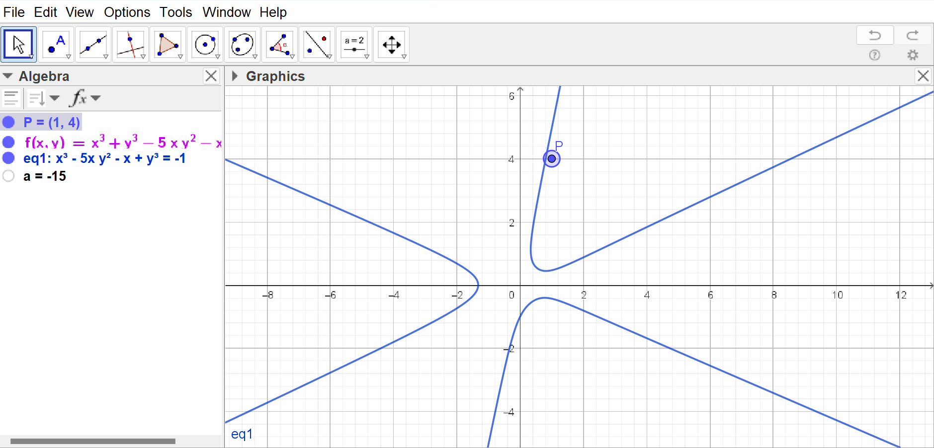
Fig – 7(c)
In the figure 7(c), we can see that the point P is not on the curve. If we plugin the point in the implicit
Equation f(x,y); we can see that the result, a, is negative.
If a was 0 for point P; we could have said that the point is on the curve. But the negative value means that
Point is inside the graph. If the value was positive, that would have meant that the point was outside of
the Graph.

Problem – 8:
The statement is partially true. If multiplicity of the polynomial is greater than 1, then the statement holds
True. In case of the multiplicity being 1, then the statement does not hold true
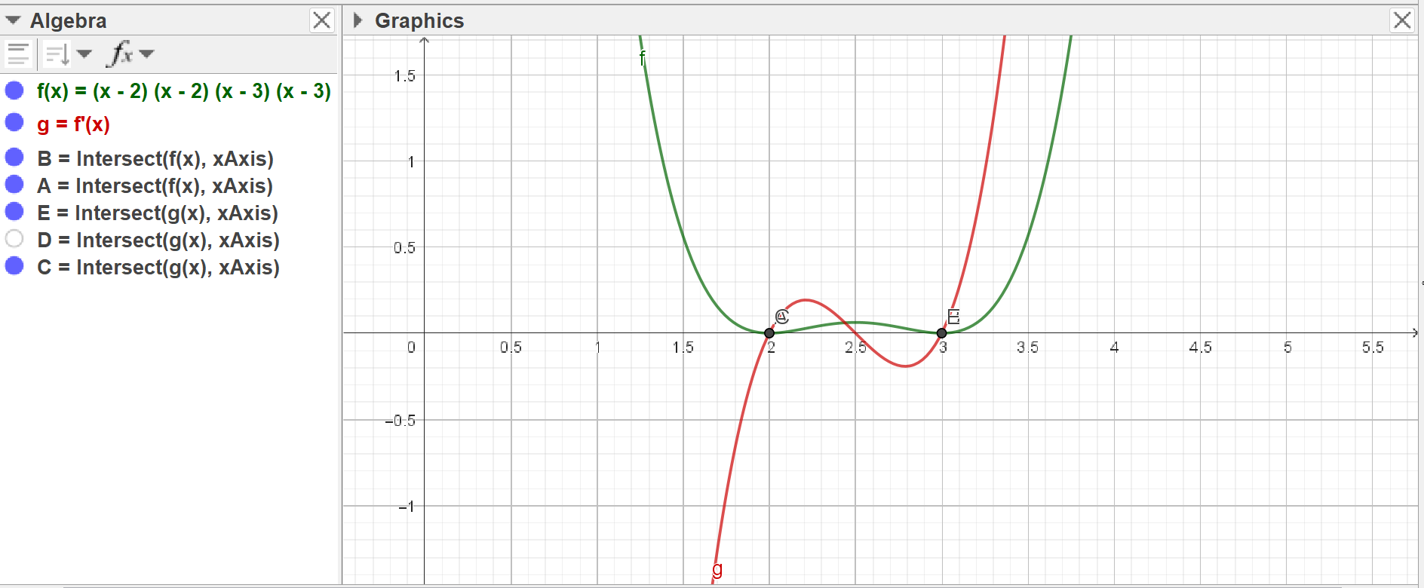
Fig – 8(a): Multiplicity >1
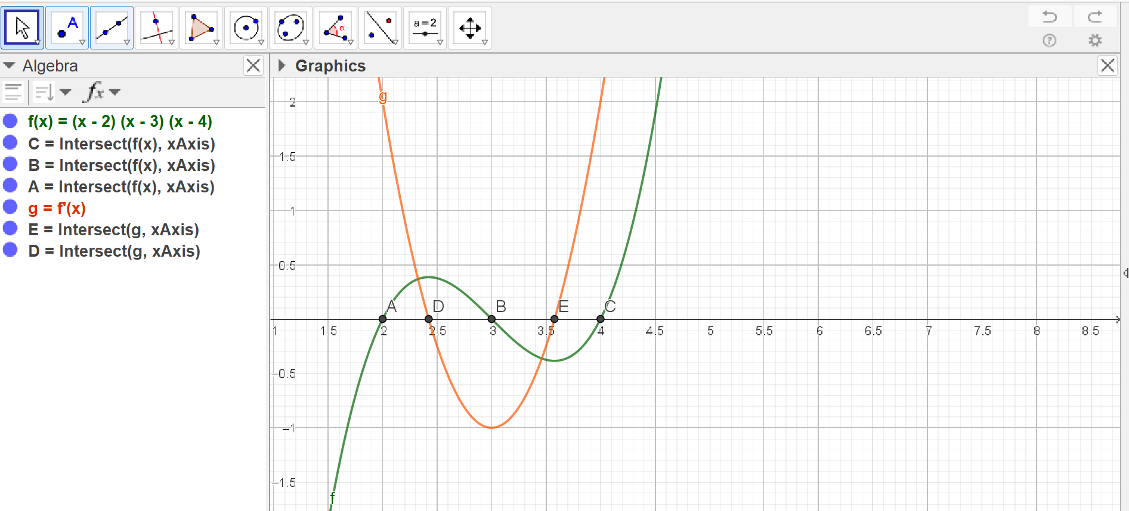
Fig – 8(b): Multiplicity == 1
Problem – 9:
The statement is false. A line segment can be expressed with parametric form
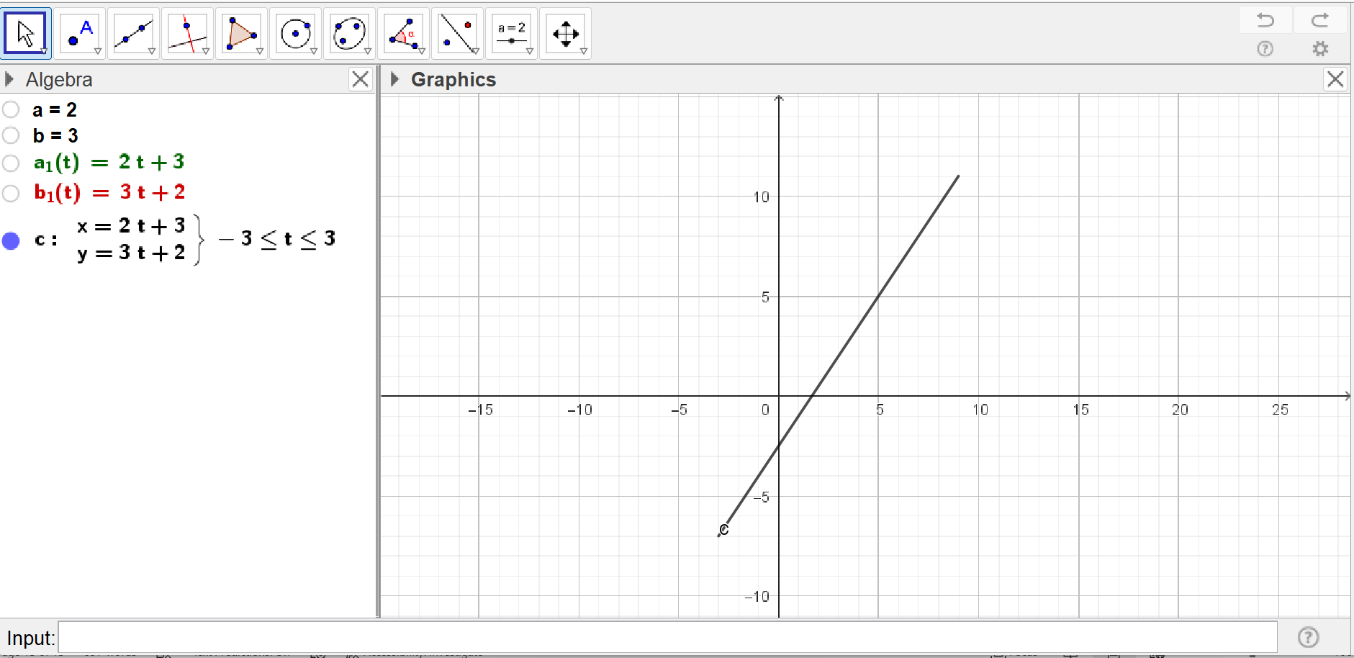
Fig – 9: A line segment and it’s parametric form

Problem – 10:
- The relation is a function. As no domain has more than one range, this relation can be considered as a function. This statement can further be validated by applying Fitpoly function with degree 3 polynomial

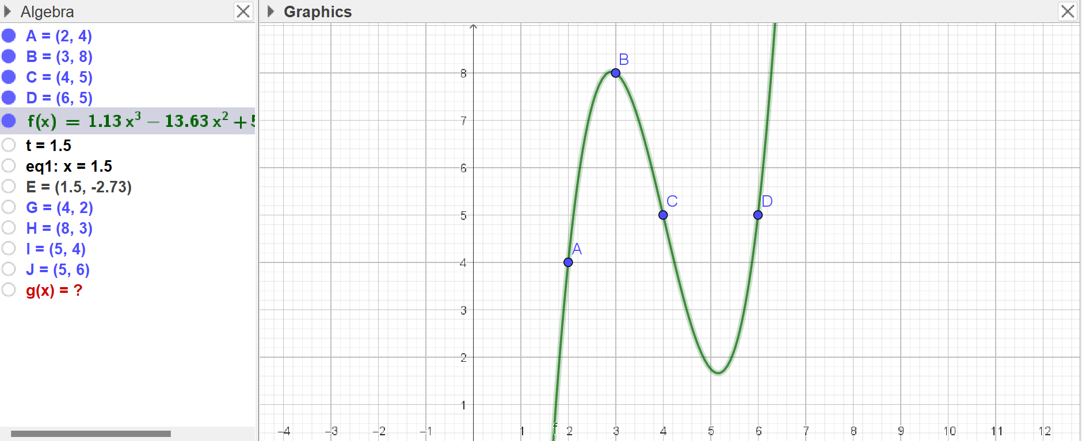
Fig – 10(a)
- As A is true, B is naturally false
- This statement is False
- This statement is true. Because I and J point of the inverse function shares the same range; which is why it is not a function. In fact, if we try to apply FitPoly function; we can see that geogebra does not do anything.
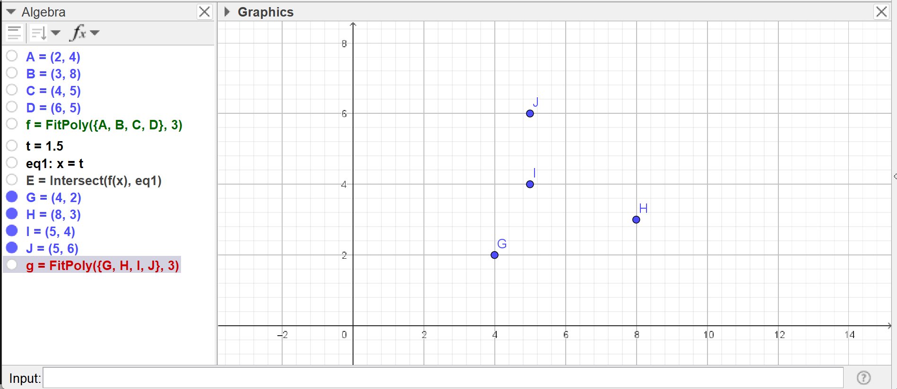
Fig – 10(b)
- As shown in the picture, {2,3,4,6} are the set of domain which belongs to A. So A set can be considered as the domain of the function f.
- B set does not contain all the points. So, it is not domain set of function f.

Problem – 11:
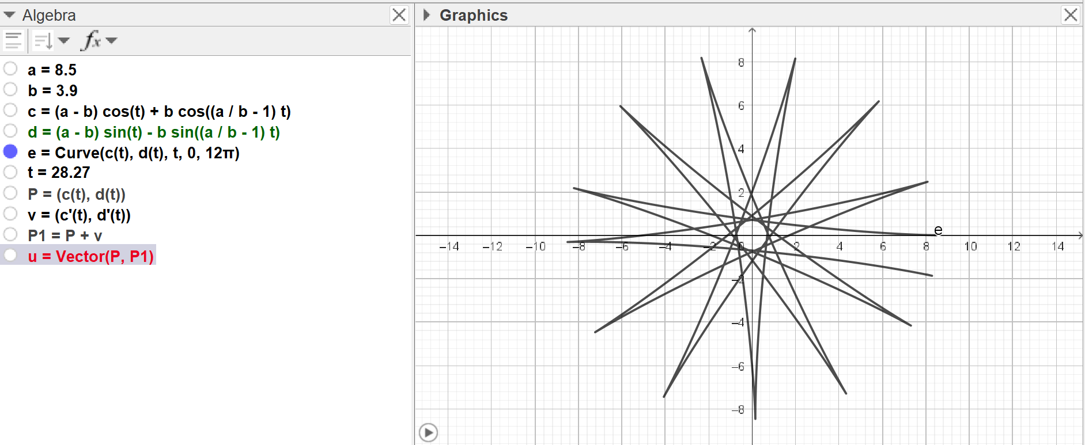
Fig – 11(a)
The above figure is the graph of the parametric curve e, defined in the interval [0,12π]

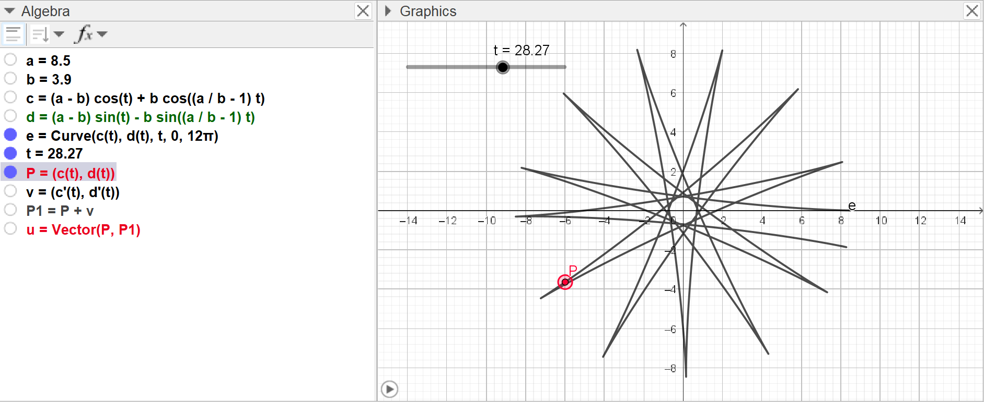
Fig – 11(b)

The above figure shows point P; which corresponds to the parameter value t = 9π.
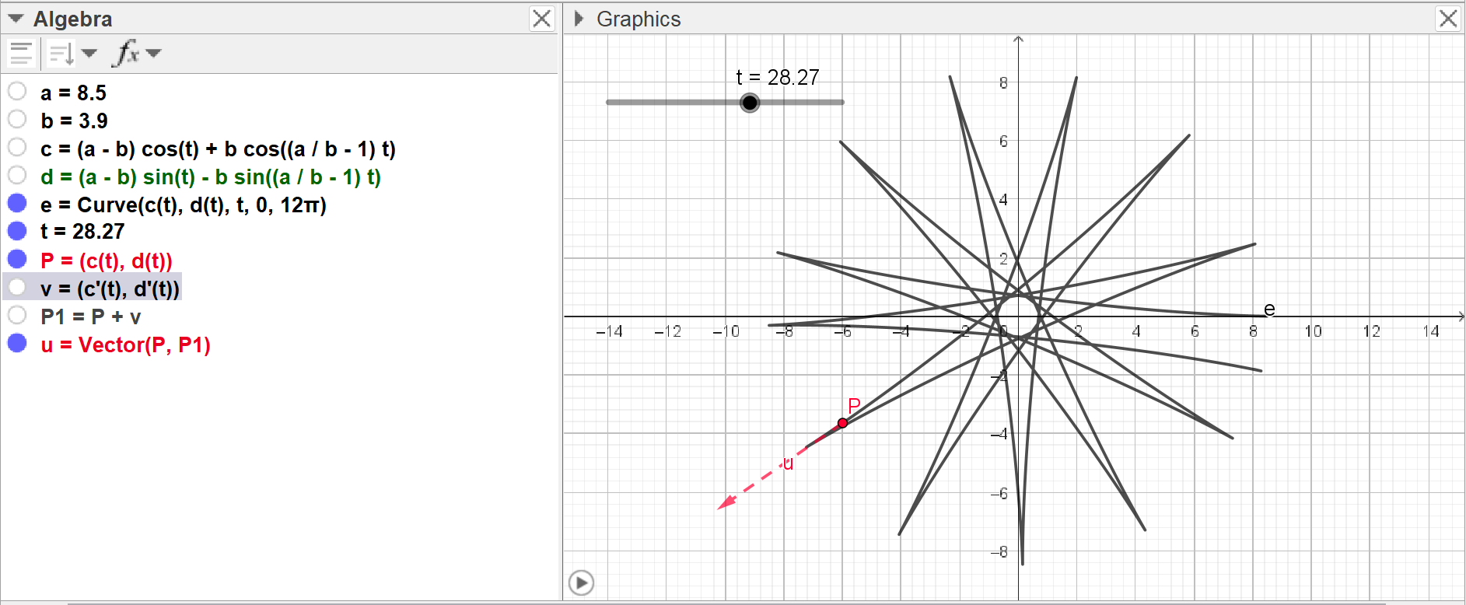
Fig – 11(c)
The above figure shows the tangent vector u; whose tail point is at P and head is at P1.

Problem – 12:
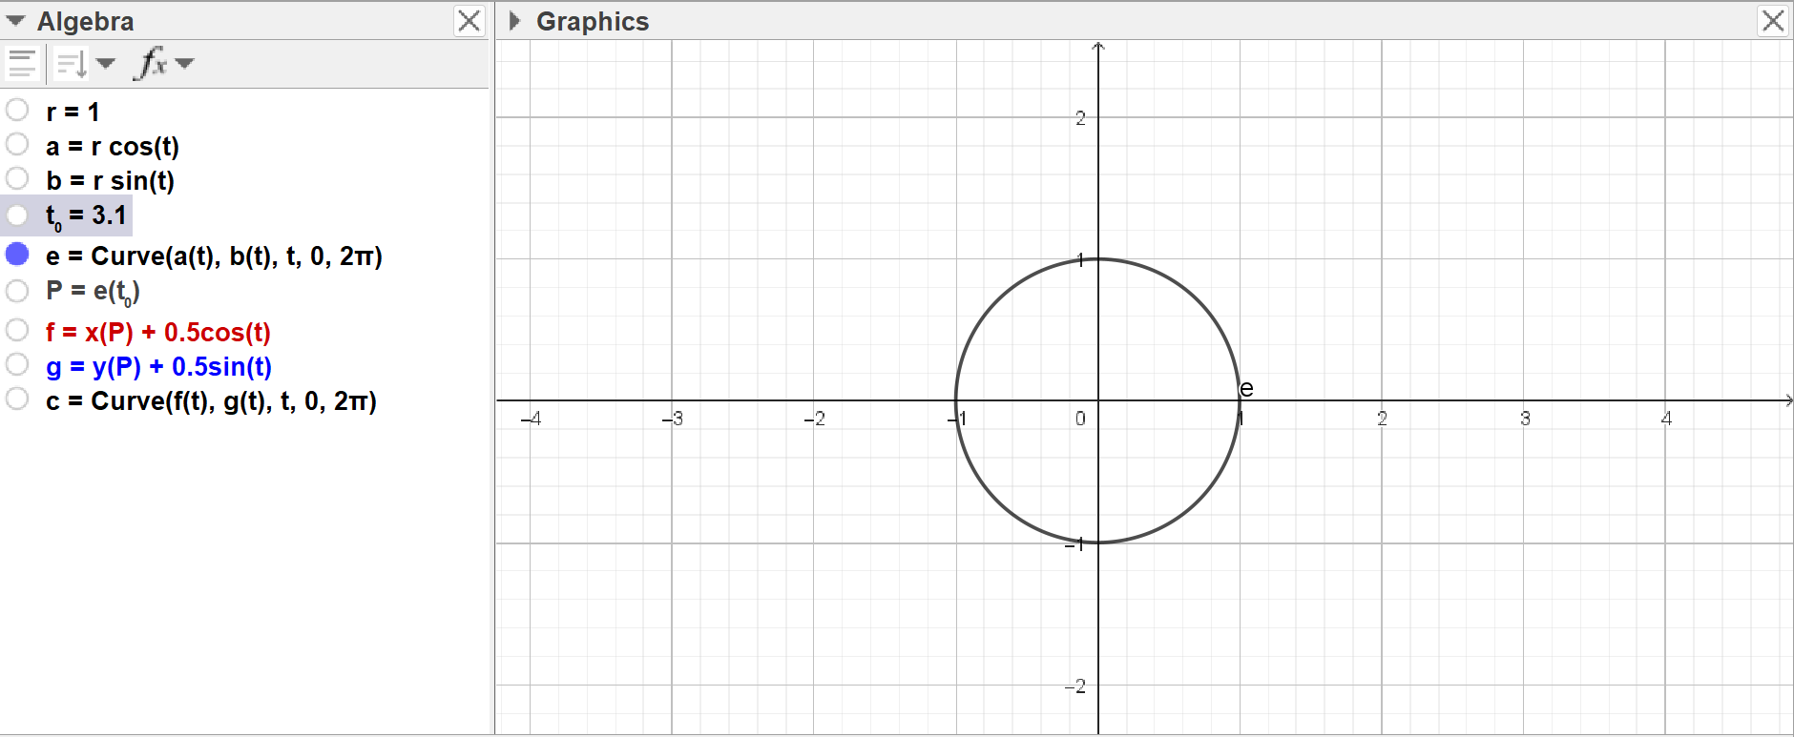
Fig – 12(a): unit circle centered at origin defined with the parametric eq e

The parameters a = rcos(t) and b = rsin(t) was used to draw the unit circle
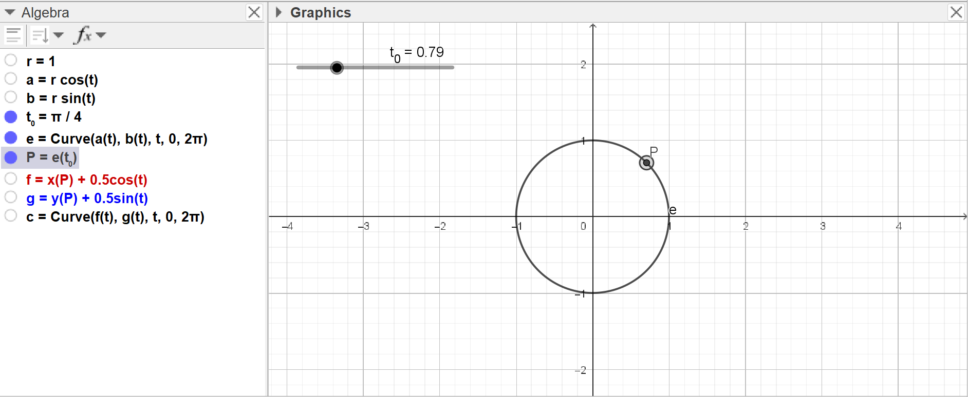
Fig – 12(b): P point corresponding to parameter value, t₀ = π/4

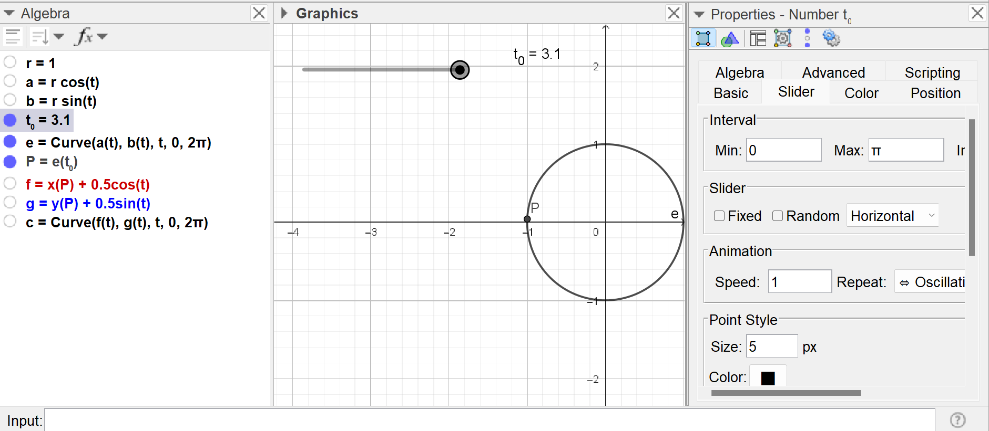
Fig – 12(c): Creation of t₀ slider with [0,π] interval

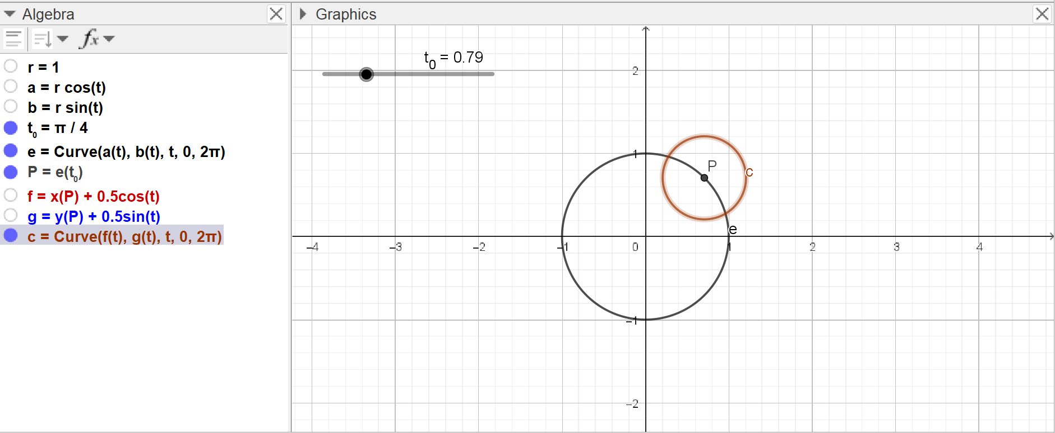
Fig – 12(d): Circle c with 0.5 radius centered at P point

As instructed in the previous questions, P point is dependent on t₀ parameter value, which has the interval of [0,π]. Which is why the circle will move in the upper half of the parent circle.

Fig – 12(e): Simulation of the circle movement in 12(d) figure

Problem – 13:

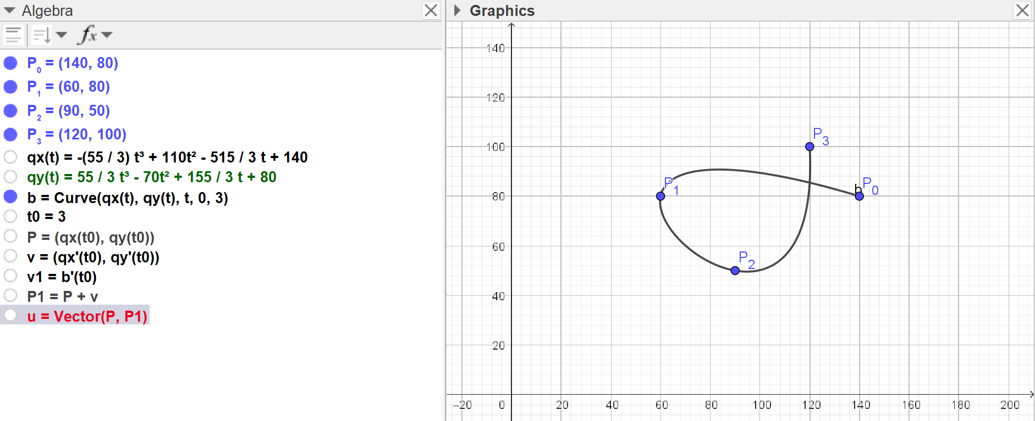
Fig – 13(a)

We know that, a third degree polynomial have the general form –
f(x) = ax³+bx²+cx+d
By plugging in the actual points, The values of a,b,c and d was calculated for qx(t) and qy(t).
The final parametric form was-
qx(t) = -(55/3)t³+110t²-(515/3)t +140
qy(t) = (55/3)t³-70t²+(155/3)t + 80
Curve command was applied with the parameter variable t over these functions with the interval [0,3]. Where the starting point is P₀ and ending point is P_{3.} The final figure is figure in 13(a)

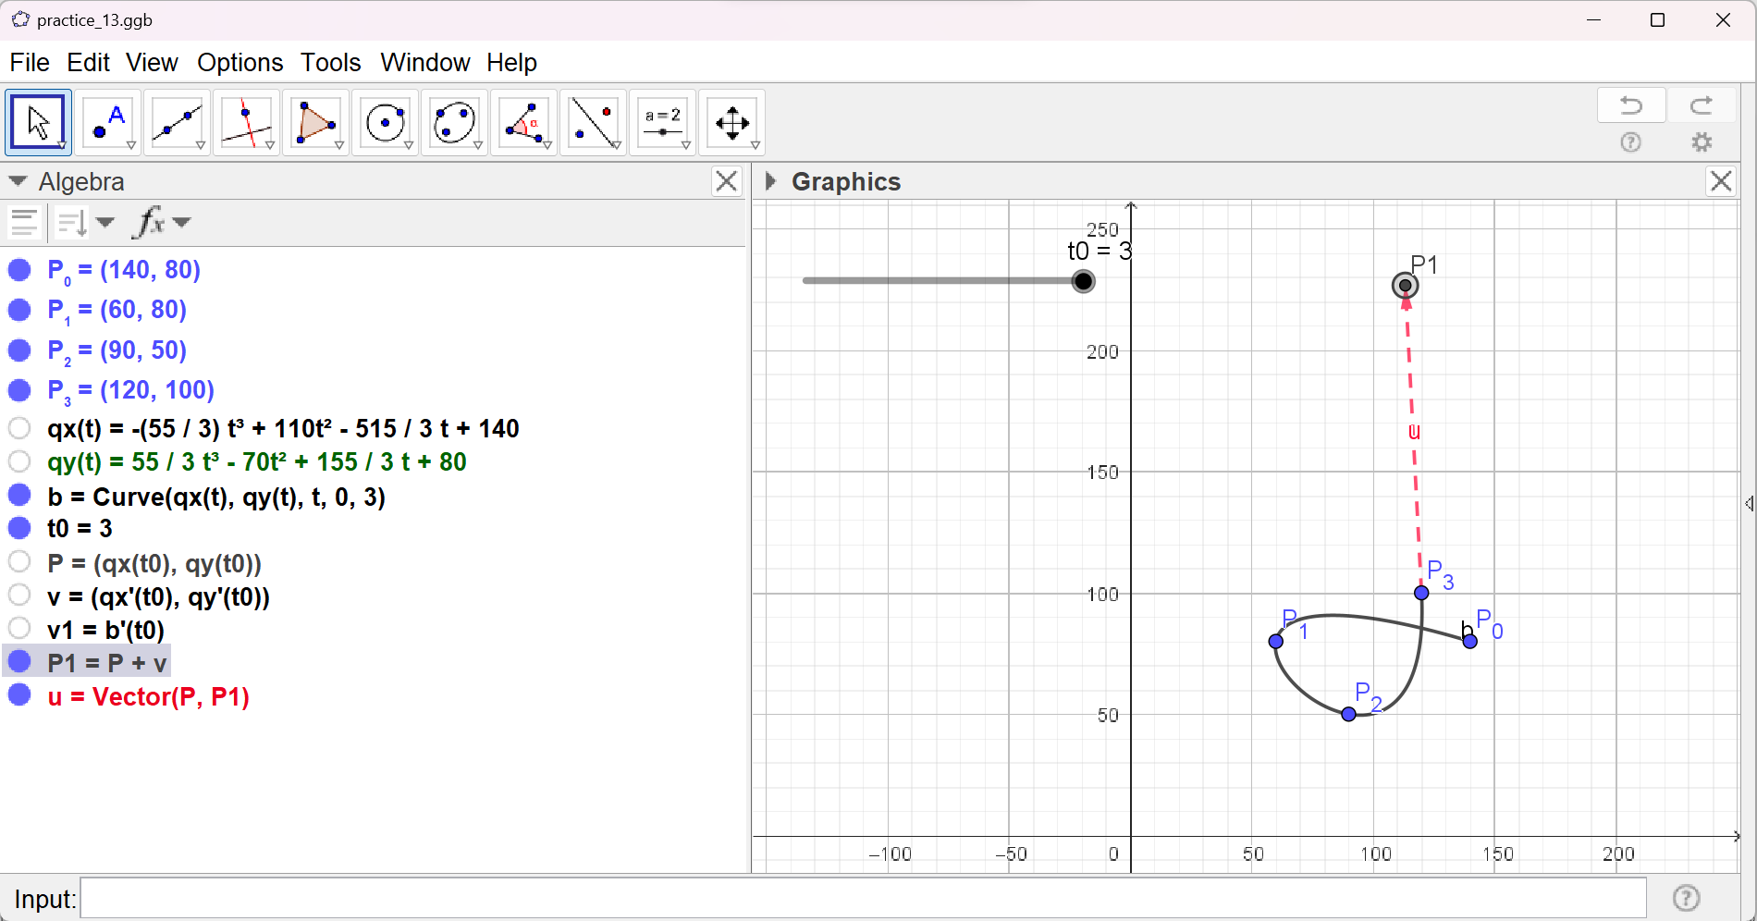
Fig – 13(b): Tangent vector at P₃

